SET 16:
1.Create a line chart to visualize the stock prices of three companies (Stock A, Stock B, and Stock C) over a specific time period. Label the axes and title the chart.
Code:
data <- data.frame(
Date=as.Date(c("2023-01-01","2023-01-02","2023-01-03")),
A=c(100,105,110), B=c(150,152,148), C=c(120,118,122))
plot(data$Date,data$A,type="o",ylim=c(90,160),
xlab="Date",ylab="Stock Price",main="Stock Prices")
lines(data$Date,data$B,type="o")
lines(data$Date,data$C,type="o")
legend("topleft",c("Stock A","Stock B","Stock C"),lty=1)
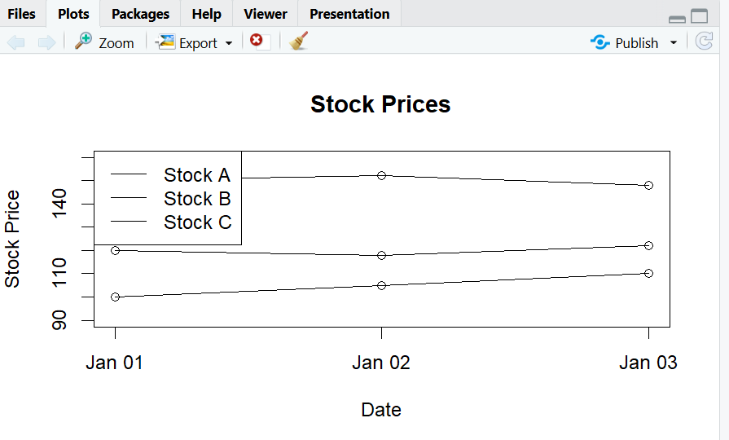
2. Generate a bar chart showing the daily percentage change in stock prices for Stock A. Label the chart elements.
Code:
import matplotlib.pyplot as plt
a = [100,105,110]
change = [(a[i]-a[i-1])/a[i-1]*100 for i in range(1,len(a))]
plt.bar(["Jan 2","Jan 3"],change)
plt.xlabel("Date")
plt.ylabel("Percentage Change (%)")
plt.title("Stock A Daily Percentage Change")
plt.show()

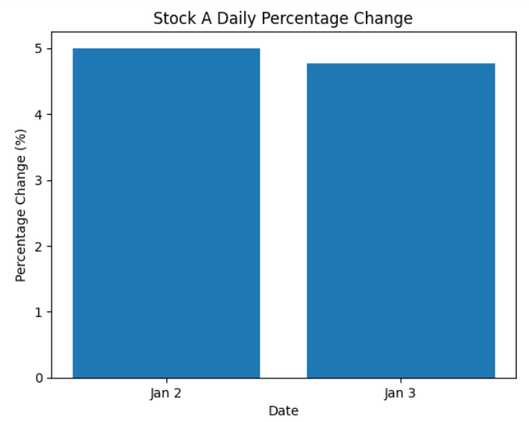
3. Build a table to display the stock price data for each company over the given period. Label the table elements.
Code:
import pandas as pd
df = pd.DataFrame({
"Date":["2023-01-01","2023-01-02","2023-01-03"],
"Stock A":[100,105,110],
"Stock B":[150,152,148],
"Stock C":[120,118,122]})
print(df)
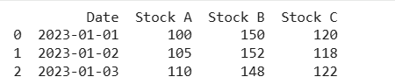

SET 17
1.In Python, create a histogram to visualize the distribution of customer ages. Label the axes
and title the chart.
Code:
import matplotlib.pyplot as plt
age = [28,35,42,30,45]
plt.hist(age,bins=5,edgecolor="black")
plt.xlabel("Age")
plt.ylabel("Number of Customers")
plt.title("Customer Age Distribution")
plt.show()
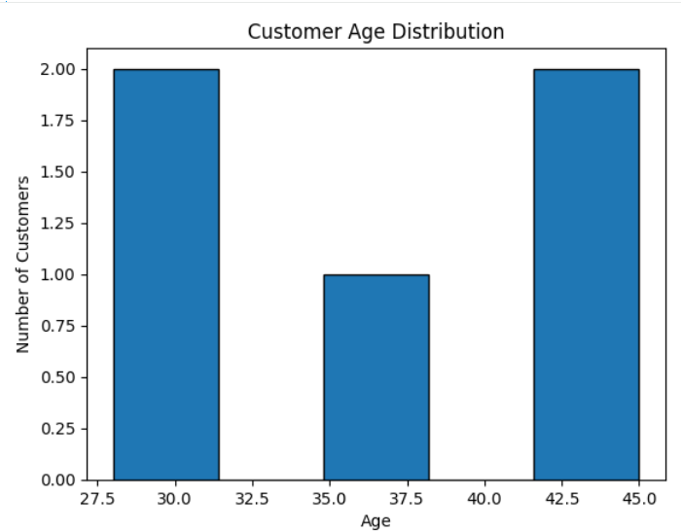
2. In R, generate a pie chart to represent the distribution of overall customer satisfaction scores.
Code:
Include labels.
score <- c(4,5,3,4,5)
count <- table(score)
pie(count,
labels=paste(names(count),count),
main="Customer Satisfaction Scores")
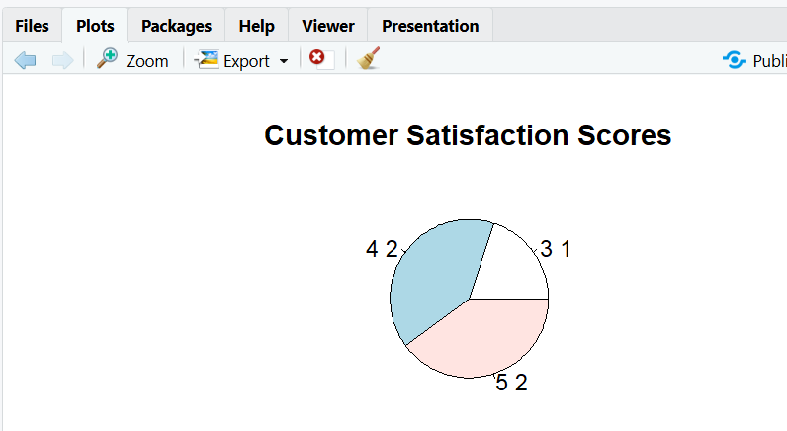
4. In Python, perform sentiment analysis on open-ended customer feedback and create a word
cloud visualization.
Code:
from textblob import TextBlob
from wordcloud import WordCloud
import matplotlib.pyplot as plt
feedback = "Excellent service and friendly staff. Very happy with the product. Good experience."
sentiment = TextBlob(feedback).sentiment.polarity
print("Sentiment:", sentiment)
wordcloud = WordCloud(width=800,height=400).generate(feedback)
plt.imshow(wordcloud)
plt.axis("off")
plt.title("Customer Feedback Word Cloud")
plt.show()
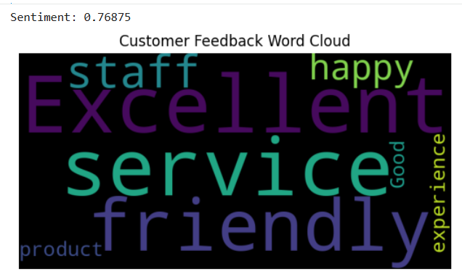

SET 18
5. In R, create a time series line chart to visualize the trend in monthly sales. Label the axes and
title the chart.
Code:
sales <- c(15000,18000,22000,20000,23000)
ts_data <- ts(sales,start=c(2023,1),frequency=12)
plot(ts_data,type="o",
xlab="Month",ylab="Sales ($)",
main="Monthly Sales Trend")
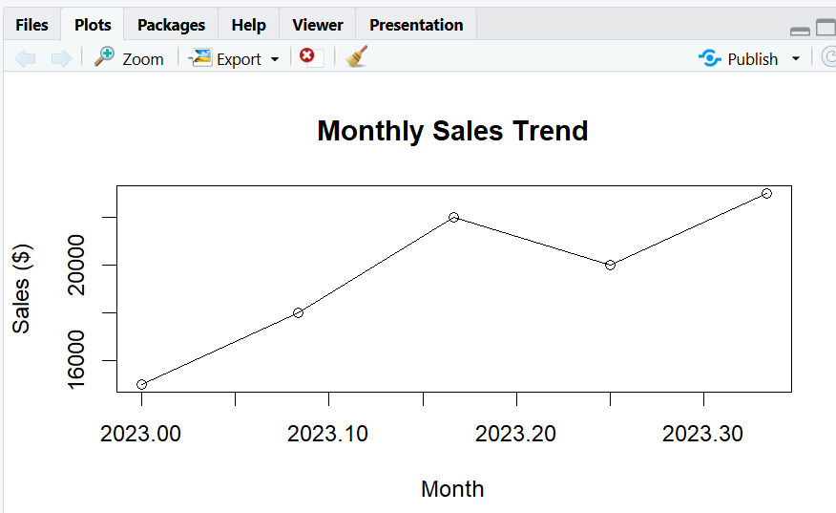

6. In Python, generate a scatter plot to analyze the relationship between advertising budget and
monthly sales. Explain any insights.
Code:
import matplotlib.pyplot as plt
advertising = [2000,2500,3000,2800,3500]
sales = [15000,18000,22000,20000,23000]
plt.scatter(advertising,sales)
plt.xlabel("Advertising Budget ($)")
plt.ylabel("Sales ($)")
plt.title("Advertising vs Monthly Sales")
plt.show()
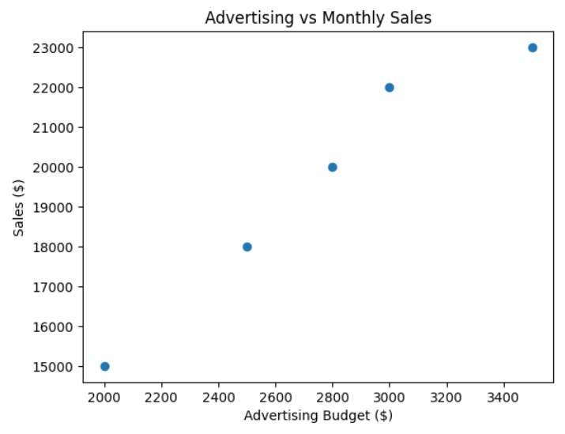

8. In R, create an autocorrelation plot to identify seasonality in the time series data
Code:
sales <- ts(c(15000,18000,22000,20000,23000),frequency=12)
acf(sales,main="Autocorrelation of Monthly Sales").
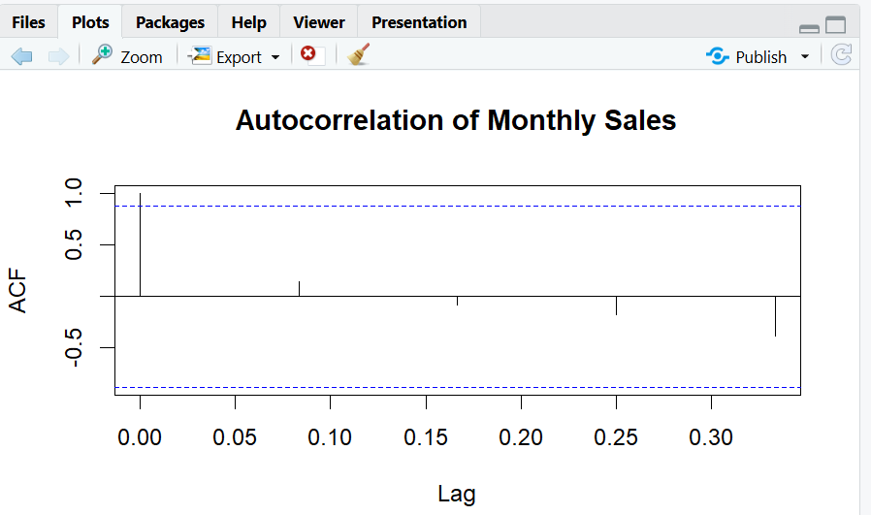

SET 19
9.In Python, create a bar chart to visualize the distribution of employees across different
departments. Label the chart elements.
Code:
import matplotlib.pyplot as plt
from collections import Counter
dept = ["Sales","HR","Marketing","Sales","HR"]
count = Counter(dept)

plt.bar(count.keys(),count.values())
plt.xlabel("Department")
plt.ylabel("Number of Employees")
plt.title("Employees by Department")
plt.show()
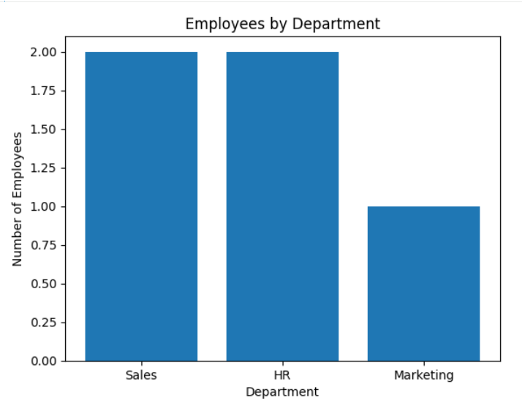

10. In R, generate a line chart to visualize the performance trend of employees over time. Label
the axes and title the chart.
Code:
years <- c(5,3,7,4,2)
score <- c(85,92,78,90,76)
plot(years,score,type="o",
xlab="Years of Service",
ylab="Performance Score",
main="Employee Performance Trend")
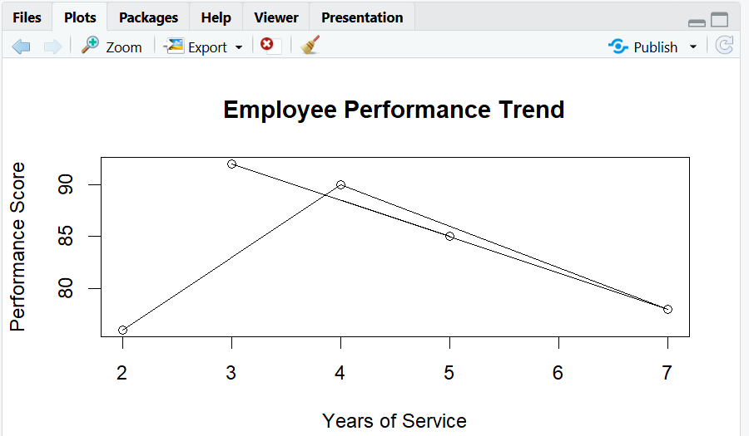

12. In Python, develop a table showing the performance data for each employee. Label the table
Code:
elements.
import pandas as pd
df = pd.DataFrame({
"Employee ID":[1,2,3,4,5],
"Department":["Sales","HR","Marketing","Sales","HR"],
"Years":[5,3,7,4,2],
"Performance":[85,92,78,90,76]})
print(df)
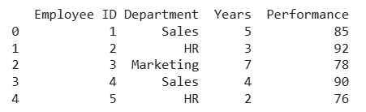

SET 20
13. In R, create a bar chart to visualize the quantity of each product in the inventory. Label the
axes and title the chart.
Code:
product <- c("A","B","C","D","E")
quantity <- c(250,175,300,200,220)
barplot(quantity,names.arg=product,
xlab="Product",ylab="Quantity",
main="Product Inventory")
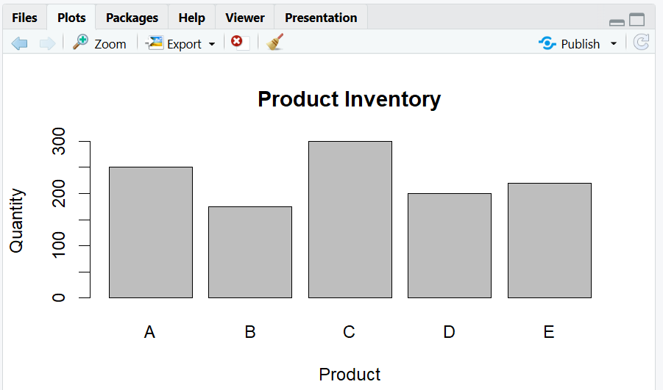

14. In Python, generate a stacked bar chart to show the quantity of each product within different
product categories.
Code:
import matplotlib.pyplot as plt
electronics = [250,175,220]
furniture = [300,200]
plt.bar(["Electronics"],[sum(electronics)],label="Electronics")
plt.bar(["Furniture"],[sum(furniture)],label="Furniture")
plt.ylabel("Quantity")
plt.title("Inventory by Category")
plt.legend()
plt.show()
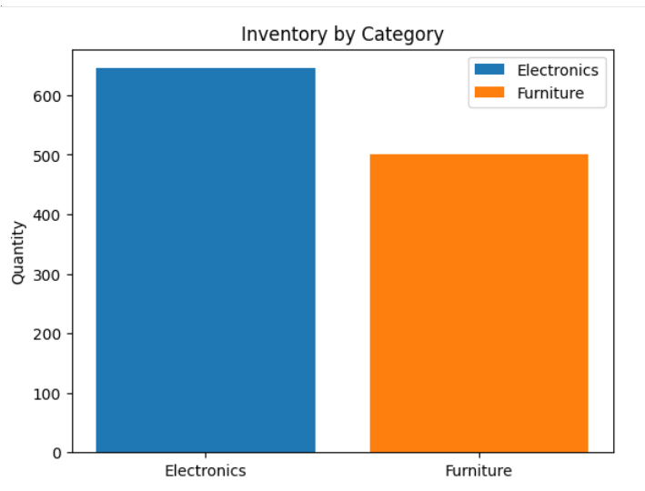

16. In Python, create a scatter plot to explore the relationship between product price and quantity
Code:
available. Explain any insights.
import matplotlib.pyplot as plt
price = [500,300,700,450,600]
quantity = [250,175,300,200,220]
plt.scatter(price,quantity)
plt.xlabel("Product Price")
plt.ylabel("Quantity Available")
plt.title("Price vs Inventory Quantity")
plt.show()
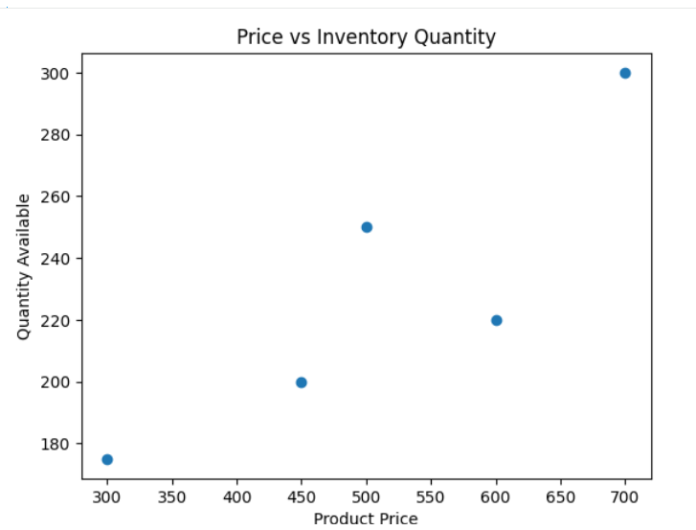

SET 21
18. In R, generate a bar chart to show the top N days with the highest click-through rates. Label
the chart elements.
Code:
data <- data.frame(
Date=as.Date(c("2023-01-01","2023-01-02","2023-01-03",
"2023-01-04","2023-01-05")),
CTR=c(2.3,2.7,2.0,2.4,2.6))
top <- head(data[order(-data$CTR),],3)
barplot(top$CTR,names.arg=top$Date,
xlab="Date",ylab="Click-through Rate (%)",
main="Top 3 Days by CTR")

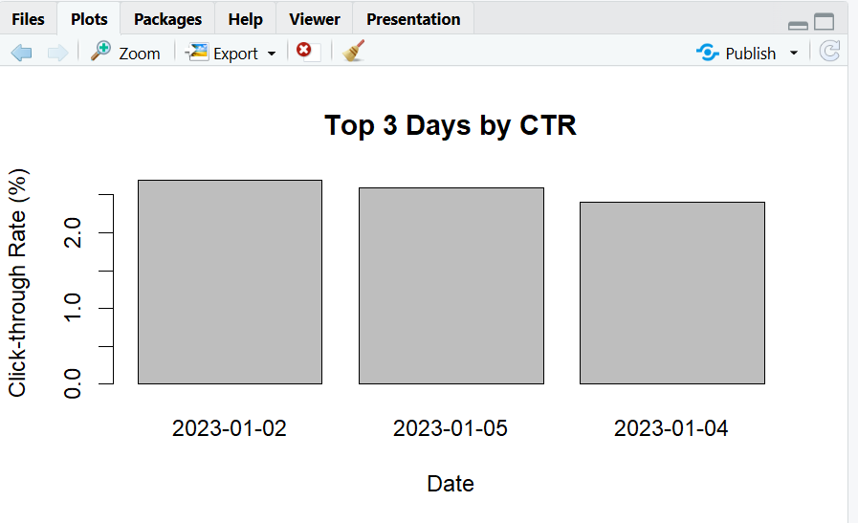
19. In Python, build a stacked area chart to display the distribution of user interactions (likes,
shares, comments) on the website.
Code:
import matplotlib.pyplot as plt

dates = ["Jan 1","Jan 2","Jan 3","Jan 4","Jan 5"]
likes = [500,600,450,650,700]
shares = [150,180,130,170,200]
comments = [80,100,70,90,120]
plt.stackplot(dates,likes,shares,comments,
labels=["Likes","Shares","Comments"])
plt.xlabel("Date")
plt.ylabel("Interactions")
plt.title("Website User Interactions")
plt.legend()
plt.show()
